**Load Libraries**

First, let’s load our favourite libraries.

|  |  |
| --- | --- |
| 1  2  3  4  5 | **library**(rvest)  **library**(readr)  **library**(tidyverse)  **library**(scales)  **library**(ggmap) |

**Figure out locations**

On its site, Shake Shack fortunately has all the locations and opening dates, going back to April 23, 2012. The archive pages run from 1 to 20 with this URL structure:

https://www.shakeshack.com/location/page/

Using SelectorGadget, I figured out the XPath and find the opening date, location name, and location page link. Then, I wrote a function to retrieve these values from a given archive page.

|  |  |
| --- | --- |
| 1  2  3  4  5  6  7  8  9  10  11  12  13  14  15  16 | get_locations <- **function**(**url**) {  page_html <- read_html(**url**)  nodes <- page_html %>%  html_nodes(xpath = '//*[contains(concat( " ", @class, " " ), concat( " ", "span4", " " ))]')    **data.frame**(opdate = html_nodes(x = nodes,  xpath = '//*[contains(concat( " ", @class, " " ), concat( " ", "date", " " ))]') %>%  html_text(trim = TRUE),  store_loc_name = html_nodes(x = nodes,  css = 'h2') %>%  html_text(trim = TRUE),  store_loc_link = html_nodes(x = nodes,  css = 'h2 a') %>%  html_attr("href"),  stringsAsFactors = FALSE)  } |

I applied this function to retrieve all location opening dates, names, and individual location urls:

|  |  |
| --- | --- |
| 1  2  3 | all_loc_pages <- paste0("https://www.shakeshack.com/location/page/", 1:20, "/")    all_locations <- **do.call**(**rbind**, **lapply**(all_loc_pages, get_locations)) |

**Find addresses of all locations**

If you visit an individual location’s page, such as [this Tokyo Dome page,](https://www.shakeshack.com/location/tokyo-japan-tokyo-dome) you will see that often the exact address is not listed, or if it is, you can’t directly geocode it. But, luckily, there’s a Google Map right below the location. I thought, they must be passing some parameters to Google Maps API. I spend a good amount of time, but couldn’t figure out how they were getting the map. And. Then. I found out that the text “CLICK MAP FOR DIRECTIONS” block had a valid address as part of the hyperlink!!



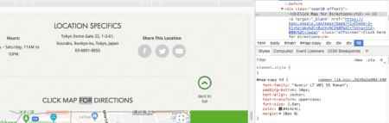

I wrote another simple function to get the addresses from the given URL:

|  |  |
| --- | --- |
| 1  2  3  4  5  6  7  8  9  10 | get_loc_cords <- **function**(loc_url) {  location_html <- read_html(loc_url)  **data.frame**(loc_url = loc_url,  goog_map_url = location_html %>%  html_nodes(xpath = '//a[text()="Click here for directions"]') %>%  html_attr("href"),  stringsAsFactors = FALSE)  }    location_google_maps_address <- **do.call**(**rbind**, **lapply**(all_locations$store_loc_link, get_loc_cords)) |

Then I joined the location name with the address data frame:

|  |  |
| --- | --- |
| 1 | all_locations <- left_join(all_locations, location_google_maps_address, **by** = **c**("store_loc_link" = "loc_url")) |

**Geocoding the addresses**

Using the fantastic ggmap library and mutate_geocode function, I geocoded all the addresses:

|  |  |
| --- | --- |
| 1  2  3 | all_locations <- all_locations %>%  mutate(google_addr_string = str_sub(goog_map_url, **start** = 36)) %>%  mutate_geocode(google_addr_string, output = "latlon") |

Here’s what the data frame looks like now:

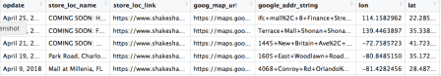

**Tip**

You may want to create a Google developer key for mass geocoding. Since the mutate_geocode function is used by many people, sometimes you may not get all the addresses geocoded. Use register_google(key = , account_type = 'premium', day_limit = 100000) function to register your key with ggmap functions.

**Data manipulation**

Now that we have all the geographical coordinates, we just need to do some clean-up to get the data ready for plotting.

First, get the date field in order and add opening month and year columns:

|  |  |
| --- | --- |
| 1  2  3  4 | all_locations <- all_locations %>%  mutate(open_date = **as.Date**(opdate, "%B %d, %Y"),  open_month = lubridate::month(open_date),  open_year = lubridate::year(open_date)) |

Second, get the cumulative count of store openings:

|  |  |
| --- | --- |
| 1  2  3  4  5 | ss_op_data_smry <- all_locations %>%  count(open_date) %>%  ungroup() %>%  arrange(open_date) %>%  mutate(cumm_n = **cumsum**(n)) |

Third, join the summary back to the locations data frame:

|  |  |
| --- | --- |
| 1  2 | all_locations_smry <- inner_join(all_locations, ss_op_data_smry,  **by** = **c**("open_date" = "open_date")) |

**Get the maps ready**

Using the ggmap library, I got the US map and a world map:

|  |  |
| --- | --- |
| 1  2 | us_map <- get_stamenmap(**c**(left = -125, bottom = 24, right = -67, top = 49), zoom = 5, maptype = "toner-lite")  ggmap(us_map) |

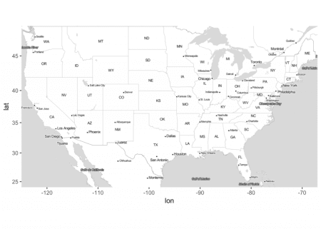

|  |  |
| --- | --- |
| 1  2 | world_map <- get_stamenmap(bbox = **c**(left = -180, bottom = -60, right = 179.9999, top = 70), zoom = 3, maptype = "toner-lite")  ggmap(world_map) |

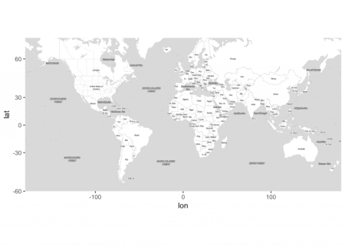

**Create functions to plot each location**

I wrote a similar function to plot locations with two different sizes: big, if the locations opened during the mapped month, and small, if the locations opened before the mapped month. I did so that we could notice the new locations.

|  |  |
| --- | --- |
| 1  2  3  4  5  6  7  8  9  10  11  12  13  14  15  16 | my_us_plot <- **function**(**df**, plotdate, mapid){  g <- ggmap(us_map, darken = **c**("0.8", "black"), extent = "device")  old_df <- **filter**(**df**, open_date < plotdate)  new_df <- **filter**(**df**, open_date == plotdate)  # old locations  g <- g + geom_point(**data** = old_df, aes(x = lon, y = lat), size = 5, color = "dodgerblue", alpha = 0.4)  # new locations  g <- g + geom_point(**data** = new_df, aes(x = lon, y = lat), size = 8, color = "dodgerblue", alpha = 0.4)  g <- g + theme(axis.ticks = element_blank(), axis.title = element_blank(), axis.text = element_blank(), plot.title = element_blank(), panel.background = element_rect(fill = "grey20"), plot.background = element_rect(fill = "grey20"))  g <- g + annotate("text", x = -77, y = 33, label = "MONTH/YEAR:", color = "white", size = rel(5), hjust = 0)  g <- g + annotate("text", x = -77, y = 32, label = paste0(**toupper**(**month.name**[**unique**(new_df$open_month)]), "/", **unique**(new_df$open_year)), color = "white", size = rel(6), fontface = 2, hjust = 0)  g <- g + annotate("text", x = -77, y = 31, label = "STORE COUNT:", color = "white", size = rel(5), hjust = 0)  g <- g + annotate("text", x = -77, y = 30, label = comma(**unique**(new_df$cumm_n)), color = "white", size = rel(6), fontface = 2, hjust = 0)  filename <- paste0("maps/img_" , str_pad(mapid, 7, pad = "0"), ".png")  ggsave(filename = filename, **plot** = g, width = 13, height = 7, dpi = 120, type = "cairo-png")  } |

I modified this function to map the world:

|  |  |
| --- | --- |
| 1  2  3  4  5  6  7  8  9  10  11  12  13  14 | my_world_plot <- **function**(**df**, plotdate, mapid){  g <- ggmap(world_map, darken = **c**("0.8", "black"), extent = "device")  old_df <- **filter**(**df**, open_date < plotdate)  new_df <- **filter**(**df**, open_date == plotdate)  g <- g + geom_point(**data** = old_df, aes(x = lon, y = lat), size = 5, color = "dodgerblue", alpha = 0.4)  g <- g + geom_point(**data** = new_df, aes(x = lon, y = lat), size = 8, color = "dodgerblue", alpha = 0.4)  g <- g + theme(axis.ticks = element_blank(), axis.title = element_blank(), axis.text = element_blank(), plot.title = element_blank(), panel.background = element_rect(fill = "grey20"))  g <- g + annotate("text", x = -130, y = 0, label = "MONTH/YEAR:", color = "white", size = rel(5), hjust = 0)  g <- g + annotate("text", x = -130, y = -10, label = paste0(**toupper**(**month.name**[**unique**(new_df$open_month)]), "/", **unique**(new_df$open_year)), color = "white", size = rel(6), fontface = 2, hjust = 0)  g <- g + annotate("text", x = -130, y = -20, label = "STORE COUNT:", color = "white", size = rel(5), hjust = 0)  g <- g + annotate("text", x = -130, y = -30, label = comma(**unique**(new_df$cumm_n)), color = "white", size = rel(6), fontface = 2, hjust = 0)  filename <- paste0("maps/img_" , str_pad(mapid, 7, pad = "0"), ".png")  ggsave(filename = filename, **plot** = g, width = 12, height = 6, dpi = 150, type = "cairo-png")  } |

**Create maps**

Now, the exciting part: create month-by-month maps.

US maps:

|  |  |
| --- | --- |
| 1  2  3  4 | all_locations_smry %>%  mutate(mapid = group_indices_(all_locations_smry, .dots = 'open_date')) %>%  group_by(open_date) %>%  do(pl = my_us_plot(all_locations_smry, **unique**(.$open_date), **unique**(.$mapid))) |

World maps:

|  |  |
| --- | --- |
| 1  2  3  4 | all_locations_smry %>%  mutate(mapid = group_indices_(all_locations_smry, .dots = 'open_date')) %>%  group_by(open_date) %>%  do(pl = my_world_plot(all_locations_smry, **unique**(.$open_date), **unique**(.$mapid))) |

**Create a movie**

Using ffmpeg, we can put all the images together to create a movie:

|  |  |
| --- | --- |
| 1  2  3 | # works on a mac  makemovie_cmd <- paste0("ffmpeg -framerate 8 -y -pattern_type glob -i '", paste0(**getwd**(), "/maps/"), "*.png'", " -c:v libx264 -pix_fmt yuv420p '", paste0(**getwd**(), "/maps/"), "movie.mp4'")  **system**(makemovie_cmd) |

We can use the convert function to create a gif:

|  |  |
| --- | --- |
| 1  2  3 | # https://askubuntu.com/a/43767  makegif_cmd <- paste0("convert -delay 8 -loop 0 ", paste0(**getwd**(), "/maps/"), "*.png ", "animated.gif") # loop 0 for forever looping  **system**(makegif_cmd) |

That’s it! We get nice looking videos showing location openings by each month. I was surprised to see how fast the company is opening the locations as well as how many locations it has in Asia!

**Post hoc**

Using the ggimage library, I tried creating the maps using Shake Shack’s burger icon, but they didn’t turn out as good:

|  |  |
| --- | --- |
| 1  2  3  4  5  6  7  8  9  10  11  12  13  14 | my_us_icon_plot <- **function**(**df**, plotdate, mapid){  g <- ggmap(us_map, darken = **c**("0.8", "black"))  old_df <- **filter**(**df**, open_date < plotdate)  new_df <- **filter**(**df**, open_date == plotdate)  g <- g + geom_image(**data** = old_df, aes(x = lon, y = lat), **image** = "ss-app-logo.png", **by** = "height", size = 0.03, alpha = 0.4)  g <- g + geom_image(**data** = new_df, aes(x = lon, y = lat), **image** = "ss-app-logo.png", **by** = "height", size = 0.07, alpha = 0.4)  g <- g + theme(axis.ticks = element_blank(), axis.title = element_blank(), axis.text = element_blank(), plot.title = element_blank())  g <- g + annotate("text", x = -77, y = 33, label = "MONTH/YEAR:", color = "white", size = rel(5), hjust = 0)  g <- g + annotate("text", x = -77, y = 32, label = paste0(**toupper**(**month.name**[**unique**(new_df$open_month)]), "/", **unique**(new_df$open_year)), color = "white", size = rel(6), fontface = 2, hjust = 0)  g <- g + annotate("text", x = -77, y = 31, label = "STORE COUNT:", color = "white", size = rel(5), hjust = 0)  g <- g + annotate("text", x = -77, y = 30, label = comma(**unique**(new_df$cumm_n)), color = "white", size = rel(6), fontface = 2, hjust = 0)  filename <- paste0("maps/img_" , str_pad(mapid, 7, pad = "0"), ".png")  ggsave(filename = filename, **plot** = g, width = 13, height = 7, dpi = 150, type = "cairo-png")  } |

**Fun maps**

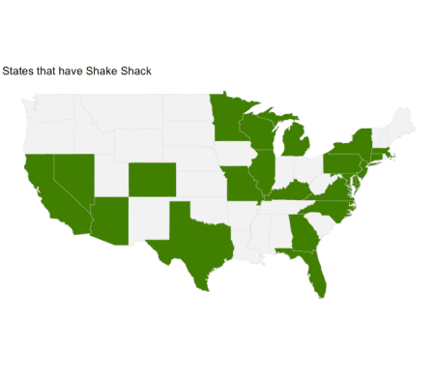

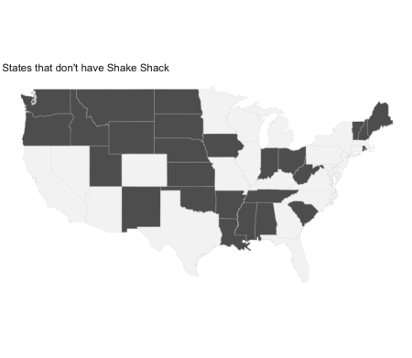

What do you think? How else would you visualize these data points?